About Canada

Canada is the world's second-largest a country by area (9.98 Million square kilometers). It is located in North America and has the longest land border with the United States. Canada is washed by three oceans. The Atlantic on the east, Pacific on the west and Arctic on the north.

Despite being so large, Canada's population is based along its southern border with the US. Canada was formed as federal dominion which today includes 10 provinces and 3 territories. Its capital is Ottawa, located on the east of Ontario province on the border with Quebec. The largest metropolitan areas are Toronto (5.9M population), Montreal (4.1M) and Vancouver (2.4M).

Canada's climate varies widely across its vast area, ranging from arctic weather in the north to hot summers in the southern regions, with four distinct seasons.

Canada is a federal parliamentary democracy and a constitutional monarchy, with Queen Elizabeth II being the head of state. The country is a realm within the Commonwealth of Nations, a member of the Francophonie and officially bilingual at the federal level. It is one of the world's most ethnically diverse and multicultural nations, the product of large-scale immigration from many other countries.

Canada is a developed country and has the fifteenth-highest nominal per capita income globally as well as the tenth-highest ranking in the Human Development Index. Its advanced economy is the tenth-largest in the world, relying mainly upon its natural resources and well-developed international trade networks.

Information in these pages is combined from various publicly available sources on the internet. Majority of the texts are taken from Wikipedia and the official site of Government of Canada

History

The history of country's name - aboriginal roots
The name “Canada” likely comes from the Huron-Iroquois word “Kanata,” meaning “village” or “settlement.” In 1535, two Aboriginal youths told French explorer Jacques Cartier about the route to Kanata; they were actually referring to the village of Stadacona, the site of the present-day City of Québec. For lack of another name, Cartier used the word “Canada” to describe not only the village but the entire area controlled by its chief, Donnacona.
By 1616, although the entire region was known as New France, the area along the great river of Canada and the Gulf of St. Lawrence was still called Canada. Soon explorers and fur traders opened up territory to the west and to the south, and the area known as Canada grew. The first use of Canada as an official name came in 1791 when the Province of Quebec was divided into the colonies of Upper Canada and Lower Canada. In 1841, the two colonies were united under one name, the Province of Canada.

Canada’s original inhabitants
Centuries before Europeans began to settle in North America, explorers who came here found thriving First Nations and Inuit societies with their own beliefs, a way of life and rich history.
When the first European explorers came to Canada they found all regions occupied by native peoples they called “Indians,” thinking they had reached the East Indies. The native people lived off the land, some by hunting and gathering, others by raising crops.
The Huron-Wendat of the Great Lakes Region, like the Iroquois, were farmers and hunters. The Cree and Dene of the Northwest were hunter-gatherers. The Sioux were nomadic, following the bison (buffalo) herd. The Inuit lived off Arctic wildlife. West Coast natives preserved fish by drying and smoking. Warfare was common among Aboriginal groups as they competed for land, resources, and prestige.
The arrival of European traders, missionaries, soldiers, and colonists changed the native way of life forever. Large numbers of Aboriginals died of European diseases to which they lacked immunity. However, Aboriginals and Europeans formed strong economic, religious and military bonds in the first 200 years of coexistence which laid the foundations of Canada.

Indigenous Peoples
The indigenous population at the time of the first European settlements is estimated to have been between 200,000[26] and two million. As a consequence of European colonization, the population of Canada's indigenous peoples declined by forty to eighty percent, and several First Nations, such as the Beothuk, disappeared.

Although not without conflict, European Canadians' early interactions with First Nations and Inuit populations were relatively peaceful. First Nations and Métis peoples played a critical part in the development of European colonies in Canada, particularly for their role in assisting European voyageurs in the exploration of the continent during the North American fur trade. From the late 18th century, European Canadians encouraged indigenous peoples to assimilate into their own culture.

Indigenous peoples in present-day Canada include the First Nations, Inuit, and Métis, the last being a mixed-blood people who originated in the mid-17th century when First Nations and Inuit people married European settlers.

European colonization
The first known attempt at European colonization began when Norsemen settled briefly at L'Anse aux Meadows in Newfoundland around 1000 AD. No further European exploration occurred until 1497 when Italian seafarer John Cabot explored and claimed Canada's Atlantic coast in the name of King Henry VII of England. In 1534, French explorer Jacques Cartier explored the Gulf of Saint Lawrence where, on July 24, he planted a 10-meter (33 ft) cross bearing the words "Long Live the King of France" and took possession of the territory New France in the name of King Francis I.

In 1583, Sir Humphrey Gilbert, by the royal prerogative of Queen Elizabeth I, founded St. John's, Newfoundland, as the first North American English colony. French explorer Samuel de Champlain arrived in 1603 and established the first permanent European settlements at Port Royal (in 1605) and Quebec City (in 1608). Among the colonists of New France, Canadiens extensively settled the Saint Lawrence River valley and Acadians settled the present-day Maritimes, while fur traders and Catholic missionaries explored the Great Lakes, Hudson Bay, and the Mississippi watershed to Louisiana. The Beaver Wars broke out in the mid-17th century over control of the North American fur trade.

The English established additional settlements in Newfoundland, beginning in 1610 and the Thirteen Colonies to the south were founded soon after. A series of four wars erupted in colonial North America between 1689 and 1763.

The Royal Proclamation of 1763 established First Nation treaty rights, created the Province of Quebec out of New France, and annexed Cape Breton Island to Nova Scotia. St. John's Island (now Prince Edward Island) became a separate colony in 1769.

After the successful American War of Independence, the 1783 Treaty of Paris recognized the independence of the newly formed United States and set the terms of peace, ceding British North American territories south of the Great Lakes to the new country. The American war of independence also caused a large out-migration of Loyalists the settlers who had fought against American independence. Many moved to Canada, particularly Atlantic Canada, where their arrival changed the demographic distribution of the existing territories. New Brunswick was in turn split from Nova Scotia as part of a reorganization of Loyalist settlements in the Maritimes which led to the incorporation of Saint John, New Brunswick to become Canada's first city. To accommodate the influx of English-speaking Loyalists in Central Canada, the Constitutional Act of 1791 divided the province of Canada into French-speaking Lower Canada (later Quebec) and English-speaking Upper Canada (later Ontario), granting each its own elected legislative assembly.

The Canadas were the main front in the War of 1812 between the United States and the United Kingdom. Peace came in 1815; no boundaries were changed. Immigration resumed at a higher level, with over 960,000 arrivals from Britain between 1815 and 1850.

The new Dominion of Canada
Today, Canada is made up of 10 provinces and three territories.

However, when the British North America Act, 1867, (now the Constitution Acts, 1867 to 1982) created the new Dominion of Canada, there were only four provinces – Ontario, Quebec, Nova Scotia, and New Brunswick.

The Northwest Territories and Manitoba

The year 1870 – three years after Confederation – brought multiple historic changes to land ownership, including:
- Canada’s purchase of Rupert’s Land from the Hudson’s Bay Company, which had been granted a charter to the area by the British government exactly two centuries earlier. Rupert's Land spanned all land drained by rivers flowing into Hudson Bay – roughly 40% of present-day Canada. The selling price was 300,000 pounds sterling.
- Britain’s transfer of the North-Western Territory to Canada. Previously, the Hudson’s Bay Company had an exclusive license to trade in this area, which stretched west to the colony of British Columbia and north to the Arctic Circle. When it was discovered in the mid-1800s that the Prairies had enormous farming potential, the British government refused to renew the company’s license. With the Hudson's Bay Company out of the area, Britain was free to turn it over to Canada.
- The combination of Rupert’s Land and the North-Western Territory to form the Northwest Territories, followed by the creation of the Province of Manitoba from a small part of this area.

British Columbia, Prince Edward Island and Yukon

Subsequent years brought more changes to Canada’s territorial boundaries:
- In 1871, British Columbia joined the union with the promise of a railway to link it to the rest of the country.
- In 1873, Prince Edward Island, which had previously declined an offer to join Confederation, became Canada's seventh province.
- Yukon, which had been a district of the Northwest Territories since 1895, became a separate territory in 1898.

Saskatchewan and Alberta

Meanwhile, Canada was opening up its west, just as its neighbor to the south had done before. Migrants from eastern Canada and immigrants from Europe and the United States began to fill the Prairies, which were still part of the Northwest Territories. Then, in 1905, the provinces of Saskatchewan and Alberta were created, completing the map of Western Canada.

Newfoundland and Nunavut

After great debate and two referenda, the people of Newfoundland voted to join Confederation in 1949, creating Canada’s tenth province.
On April 1, 1999, Nunavut was created from the eastern part of the Northwest Territories, covering 1.9 million square kilometers of Canada’s Eastern Arctic.

Early 20th century
Because Britain still maintained control of Canada's foreign affairs under the Constitution Act, 1867, its declaration of war in 1914 automatically brought Canada into World War I. Volunteers sent to the Western Front later became part of the Canadian Corps, which played a substantial role in the Battle of Vimy Ridge and other major engagements of the war. Out of approximately 625,000 Canadians who served in World War I, some 60,000 were killed and another 172,000 were wounded.

The Great Depression in Canada during the early 1930s saw an economic downturn, leading to hardship across the country. On the advice of Prime Minister William Lyon Mackenzie King, war with Germany was declared effective September 10, 1939, by King George VI, seven days after the United Kingdom. The delay underscored Canada's independence.

The first Canadian Army units arrived in Britain in December 1939. In all, over a million Canadians served in the armed forces during World War II and approximately 42,000 were killed and another 55,000 were wounded.

The Canadian economy boomed during the war as its industries manufactured military materiel for Canada, Britain, China, and the Soviet Union. Despite another Conscription Crisis in Quebec in 1944, Canada finished the war with a large army and strong economy.

Canada’s Head of State
In today's constitutional monarchy, Her Majesty Queen Elizabeth II is Queen of Canada and Canada's Head of State. She is the personal embodiment of the Crown in Canada.
In Canada’s system of government, the power to govern is vested in the Crown but is entrusted to the government to exercise on behalf and in the interest of the people. The Crown reminds the government of the day that the source of the power to govern rests elsewhere and that it is only given to them for a limited duration.​
​
​
​
Sources:
https://www.canada.ca/en/canadian-heritage/services/origin-name-canada.html
https://www.canada.ca/en/canadian-heritage/services/crown-canada/about.html
https://en.wikipedia.org/wiki/Canada
​

Geography

Canada is the second largest country on earth—10 million square kilometers. Three oceans wash Canada’s shore: the Pacific Ocean in the west, the Atlantic Ocean in the east, and the Arctic Ocean to the north. Along the southern border of Canada lies the Canada-United States boundary along the 49th parallel. ​
​
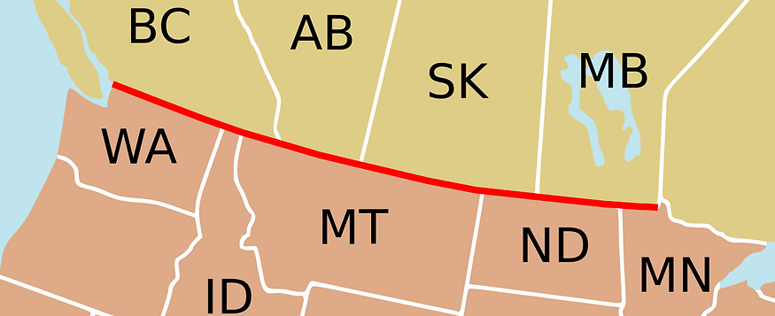

The Regions of Canada
Canada includes many different geographical areas and five distinct regions.
- The Atlantic Provinces
- Central Canada
- The Prairie Provinces
- The West Coast
- The Northern Territories

The National Capital
Ottawa, located on the Ottawa River, was chosen as the capital in 1857 by Queen Victoria, the great-great-grandmother of Queen Elizabeth II. Today it is Canada’s fourth largest metropolitan area.
​

Population
Canada has a population of about 37 million people (Dec. 2018). While the majority live in cities, Canadians also live in small towns, rural areas and everywhere in between.
​

Provinces and Territories
Canada has ten provinces and three territories. Each province and territory has its own capital city.
​
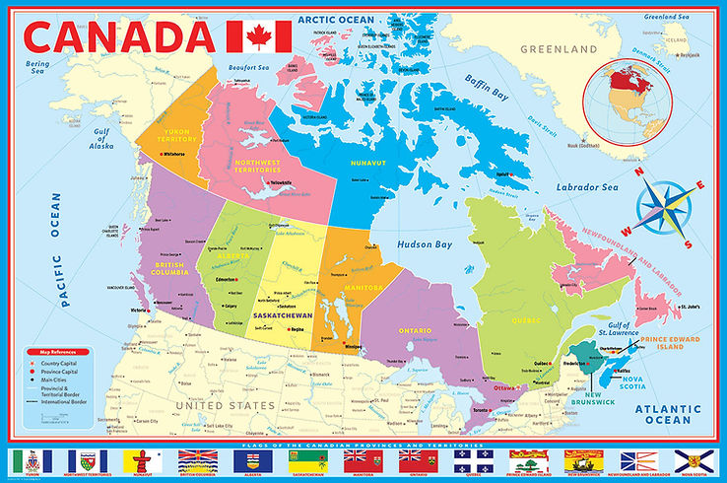

The Atlantic provinces​

​
The Atlantic provinces of Canada have natural resources, including fishing, farming, forestry, and mining. These resources have made these provinces an important part of Canada’s history and development. The Atlantic Ocean brings cool winters and cool humid summers.​
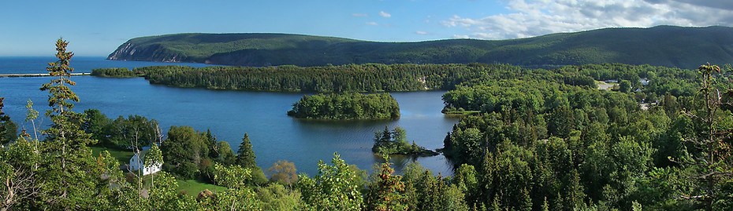

Newfoundland and Labrador
Newfoundland and Labrador is the most easterly point in North America and has its own time zone. Its time zone is half an hour off of the next one to it, making it very unique. In addition to its natural beauty, the province has a unique heritage linked to the sea. The province has long been known for its fisheries, coastal fishing villages and distinct culture. Today off-shore oil and gas extraction contributes a substantial part of the economy. Labrador also has immense hydro-electric resources.​
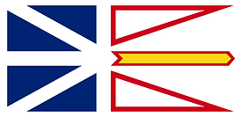
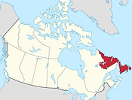
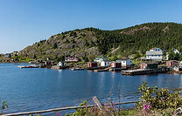


Prince Edward Island
Prince Edward Island (P.E.I.) is the smallest province, known for its beaches, red soil and agriculture, especially potatoes. P.E.I. is the birthplace of Confederation, connected to mainland Canada by one of the longest continuous multi-span bridges in the world, the Confederation Bridge.
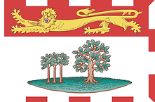
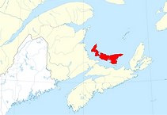
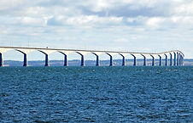
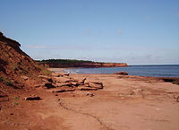

Nova Scotia
Nova Scotia is the most populous Atlantic Province, with a rich history as the gateway to Canada. Known for the world’s highest tides in the Bay of Fundy, the province’s identity is linked to shipbuilding, fisheries, and shipping. As Canada’s largest east coast port, deep-water and ice-free, the capital, Halifax, has played an important role in Atlantic trade and defense and is home to Canada’s largest naval base. Nova Scotia has a long history of coal mining, forestry and agriculture. Today there is also off-shore oil and gas exploration.
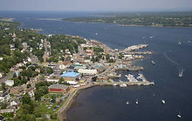
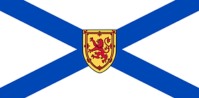
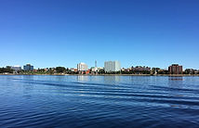
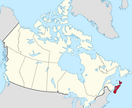

New Brunswick
The province was founded by the United Empire Loyalists and has the second largest river system on North America’s Atlantic coastline, the St. John River system. Forestry, agriculture, fisheries, mining, food processing, and tourism are the principal industries. Saint John is the largest city, port, and manufacturing center; Moncton is the principal Francophone Acadian center; and Fredericton, the historic capital. New Brunswick is the only officially bilingual province, and about one-third of the population lives and works in French.
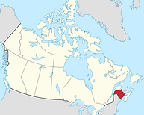
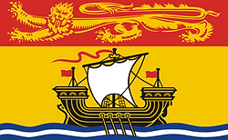
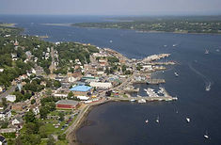
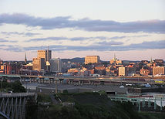

Central Canada

More than half the people in Canada live in cities and towns near the Great Lakes and the St. Lawrence River in southern Quebec and Ontario, known as Central Canada and the industrial and manufacturing heartland. Southern Ontario and Quebec have cold winters and warm humid summers. Together, Ontario and Quebec produce more than three-quarters of all Canadian manufactured goods.

Quebec
Nearly eight million people live in Quebec, the vast majority along or near the St. Lawrence River. More than three-quarters speak French as their first language. The most important industries in Quebec are forestry, energy, and mining. Quebec is Canada’s main producer of pulp and paper. The province’s huge supply of fresh water has made it Canada’s largest producer of hydro-electricity.
Quebecers are leaders in cutting-edge industries such as pharmaceuticals and aeronautics. Quebec films, music, literary works, and food have international stature, especially in La Francophonie, an association of French-speaking nations.
Montreal, Canada’s second largest city and the second largest mainly French-speaking city in the world after Paris, is famous for its cultural diversity.
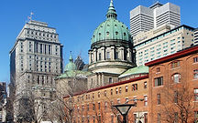
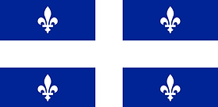
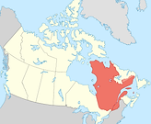
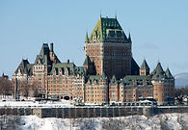

Ontario
More than 12 million people leave in Ontario, which is more than one-third of Canadians. The large and culturally diverse population, natural resources and strategic location contribute to a vital economy.
Toronto is the largest city in Canada and the country’s main financial center. Many people work in the service or manufacturing industries, which produce a large percentage of Canada’s exports. The Niagara region is known for its vineyards, wines and fruit crops. Ontario farmers raise dairy and beef cattle, poultry, and vegetable and grain crops.
There are five Great Lakes located between Ontario and the United States: Lake Ontario, Lake Erie, Lake Huron, Lake Michigan (in the U.S.A.) and Lake Superior, the largest freshwater lake in the world.
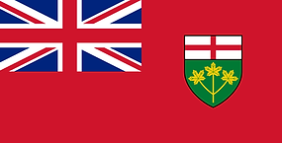
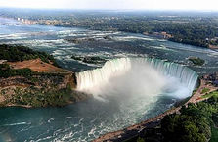
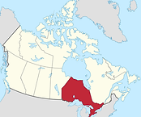
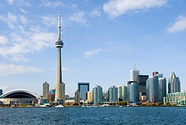

The Prairie Provinces
Manitoba, Saskatchewan, and Alberta are the Prairie Provinces, rich in energy resources and some of the most fertile farmland in the world. The region is mostly dry, with cold winters and hot summers.
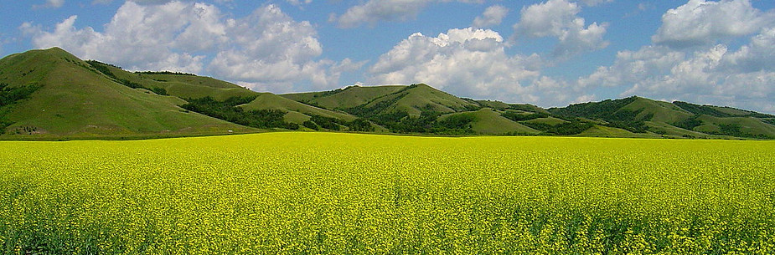

Manitoba
Manitoba’s economy is based on agriculture, mining, and hydroelectric power generation. The province’s most populous city is Winnipeg, whose Exchange District includes the most famous street intersection in Canada, Portage and Main. Manitoba is also an important center of Ukrainian culture, with 14% reporting Ukrainian origins, and the largest Aboriginal population of any province, at over 15%.
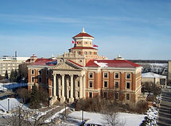
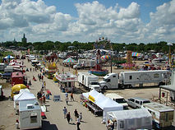
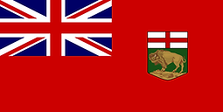
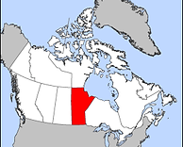

Saskatchewan
Saskatchewan, once known as the “breadbasket of the world” and the “wheat province,” has 40% of the arable land in Canada and is the country’s largest producer of grains and oilseeds. It also boasts the world’s richest deposits of uranium and potash, used in fertilizer, and produces oil and natural gas.
Regina, the capital, is home to the training academy of the Royal Canadian Mounted Police. Saskatoon, the largest city is the headquarters of the mining industry and an important educational, research and technology center.
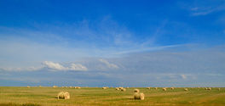
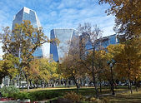
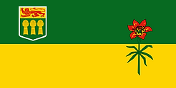
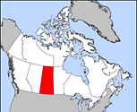

Alberta
Alberta is the most populous Prairie province. The province, and the world-famous Lake Louise in The Rocky Mountains, were both named after Princess Louise Caroline Alberta, fourth daughter of Queen Victoria.
Alberta has five national parks, including Banff National Park, established in 1885. The rugged Badlands house some of the world’s richest deposits of prehistoric fossils and dinosaur finds. Alberta is the largest producer of oil and gas, and the oil sands in the north are being developed as a major energy source.
Alberta is also renowned for agriculture, especially for the vast cattle ranches that make Canada one of the world’s major beef producers.
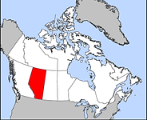
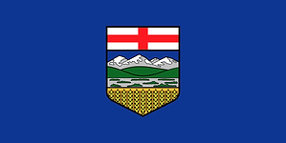
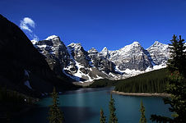
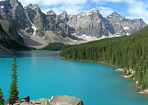

The West Coast

British Columbia is known for its majestic mountains and as Canada’s Pacific gateway. The Port of Vancouver, Canada’s largest and busiest, handles billions of dollars in goods traded around the world. Warm airstreams from the Pacific Ocean give the B.C. coast a temperate climate.

British Columbia
British Columbia (B.C.), on the Pacific coast, is Canada’s westernmost province, with a population of four million. The Port of Vancouver is the gateway to the Asia-Pacific. About one-half of all the goods produced in B.C. are forestry products, including lumber, newsprint, and pulp and paper products—the most valuable forestry industry in Canada. B.C. is also known for mining, fishing, and the fruit orchards and wine industry of the Okanagan Valley. B.C. has the most extensive park system in Canada, with approximately 600 provincial parks.
The capital, Victoria, is a tourist center and headquarters of the Navy's Pacific fleet.
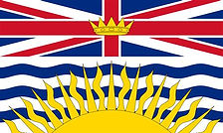
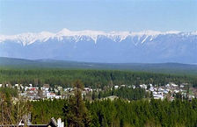
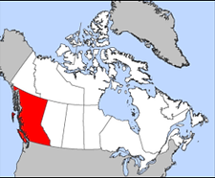
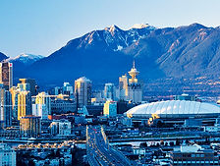

The Northern Territories
The Northwest Territories, Nunavut and Yukon contain one-third of Canada’s land mass but have a population of only 100,000. There are gold, lead, copper, diamond and zinc mines. Oil and gas deposits are being developed. The North is often referred to as the “Land of the Midnight Sun” because at the height of summer, daylight can last up to 24 hours. In winter, the sun disappears and darkness sets in for three months. The Northern territories have long cold winters and short cool summers. Much of the North is made up of tundra, the vast rocky Arctic plain. Because of the cold Arctic climate, there are no trees on the tundra and the soil is permanently frozen.
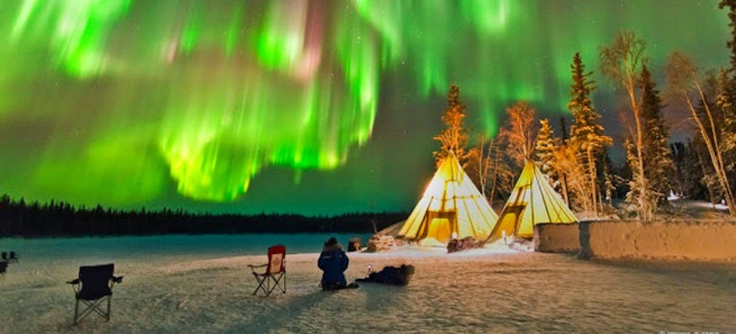

Yukon
Thousands of miners came to the Yukon during the Gold Rush of the 1890s. Mining remains a significant part of the economy. The White Pass and Yukon Railway opened from Skagway in neighboring Alaska to the territorial capital, Whitehorse, in 1900 and provides a spectacular tourist excursion across precipitous passes and bridges. Yukon holds the record for the coldest temperature ever recorded in Canada (-63°C).
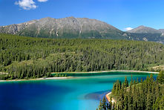
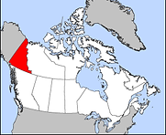
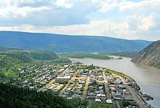
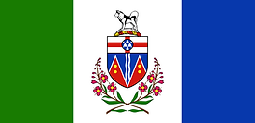

Northwest Territories
The Northwest Territories (N.W.T.) were originally made up in 1870 from Rupert’s Land and the North-Western Territory. The capital, Yellowknife (population 20,000), is called the “diamond capital of North America.” More than half the population is Aboriginal (Dene, Inuit and Métis). The Mackenzie River, at 4,200 kilometers, is the second-longest river system in North America after the Mississippi.
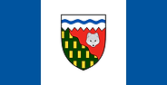
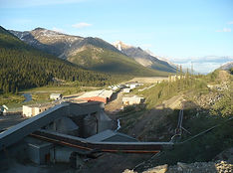
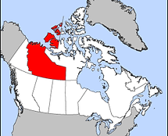
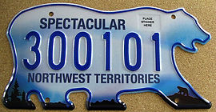

Nunavut
Nunavut, meaning “our land” in Inuktitut, was established in 1999 from the eastern part of the Northwest Territories, including all of the former District of Keewatin. The capital is Iqaluit, formerly Frobisher Bay, named after the English explorer Martin Frobisher, who penetrated the uncharted Arctic for Queen Elizabeth I in 1576. The population is about 85% Inuit, and Inuktitut is an official language and the first language in schools.
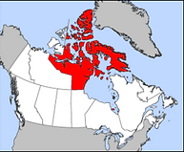
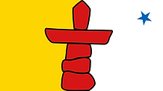
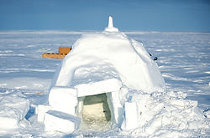
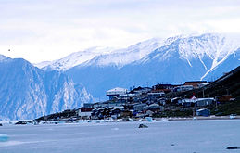

Source:

"Discover Canada The Rights and Responsibilities of Citizenship" official citizenship preparation guide - https://www.canada.ca/content/dam/ircc/migration/ircc/english/pdf/pub/discover.pdf
Demographics

The Canada 2016 Census enumerated a total population of 35,151,728. Between 2011 and May 2016, Canada's population grew by 1.7 million people, with immigrants accounting for two-thirds of the increase. Between 1990 and 2008, the population increased by 5.6 million, equivalent to 20.4 percent overall growth. The main driver of population growth is immigration.

Canada has one of the highest per-capita immigration rates in the world,[239] driven mainly by economic policy and, to a lesser extent, family reunification. The Canadian public as-well as the major political parties support the current level of immigration. In 2014, a total of 260,400 immigrants were admitted to Canada, mainly from Asia. The Canadian government anticipated between 280,000 and 305,000 new permanent residents in the following years, a similar number of immigrants as in recent years. New immigrants settle mostly in major urban areas such as Toronto, Montreal and Vancouver. Canada also accepts large numbers of refugees, accounting for over 10 percent of annual global refugee resettlements.

Canada's population density, at 3.7 inhabitants per square kilometer (9.6/sq mi), is among the lowest in the world. Canada spans latitudinally from the 83rd parallel north to the 41st parallel north, and approximately 95% of the population is found south of the 55th parallel north. About four-fifths of the population lives within 150 kilometres (93 mi) of the contiguous United States border. The most densely populated part of the country, accounting for nearly 50 percent, is the Quebec City–Windsor Corridor in Southern Quebec and Southern Ontario along the Great Lakes and the Saint Lawrence River. An additional 30 percent live along the British Columbia Lower Mainland, and the Calgary–Edmonton Corridor in Alberta.

In common with many other developed countries, Canada is experiencing a demographic shift towards an older population, with more retirees and fewer people of working age. In 2006, the average age was 39.5 years; by 2011, it had risen to approximately 39.9 years.

As of 2013, the average life expectancy for Canadians is 81 years. The majority of Canadians (69.9%) live in family households, 26.8% report living alone, and those living with unrelated persons reported at 3.7%. The average size of a household in 2006 was 2.5 people.

More detailed information about Canadian demographics can be found here on Wikipedia:
https://en.wikipedia.org/wiki/Demographics_of_Canada

Economy
Canada is the world's tenth-largest economy as of 2016, with a nominal GDP of approximately US$1.52 trillion. It is a member of the Organization for Economic Co-operation and Development (OECD) and the Group of Eight (G8), and is one of the world's top ten trading nations, with a highly globalized economy. Canada is ranked above the US and most western European nations on The Heritage Foundation's index of economic freedom, and experiencing a relatively low level of income disparity. The country's average household income per capita is over US$23,900, higher than the OECD average.

In 2014, Canada's exports totaled over C$528 billion, while its imported goods were worth over $524 billion, of which approximately $351 billion originated from the United States, $49 billion from the European Union, and $35 billion from China.

Since the early 20th century, the growth of Canada's manufacturing, mining, and service sectors has transformed the nation from a largely rural economy to an urbanized, industrial one. Like many other developed countries, the Canadian economy is dominated by the service industry, which employs about three-quarters of the country's workforce. However, Canada is unusual among developed countries in the importance of its primary sector, in which the forestry and petroleum industries are two of the most prominent components.

Main Canadian industries in 2017 were:

Real estate and rental and leasing
Manufacturing
Mining, quarrying, and oil and gas extraction
Finance and insurance
Construction
Health care and social assistance
Public administration
Wholesale trade
Retail trade
Professional, scientific and technical services
Educational services
Transportation and warehousing
Information and cultural industries
Administrative and support, waste management and remediation services
Utilities
Accommodation and food services
Other services (except public administration)
Agriculture, forestry, fishing and hunting
Arts, entertainment and recreation
Management of companies and enterprises
13.01%
10.37%
8.21%
7.07%
7.07%
6.63%
6.28%
5.78%
5.60%
5.54%
5.21%
4.60%
3.00%
2.46%

2.21%
2.15%
1.89%
1.53%
0.77%
0.62%
Source:
Wikipedia - https://en.wikipedia.org/wiki/Economy_of_Canada

Climate

It won't be a surprise to anybody, that some places in Canada have colder than any other place on earth temperatures. However, it might be a surprise. That Canada has a very diverse climate. The climate varies from temperate on the west coast of British Columbia to a subarctic climate in the north.

Extreme northern Canada can have snow for most of the year with a Polar climate. Landlocked areas tend to have a warm summer continental climate zone with the exception of Southwestern Ontario which has a hot summer humid continental climate. Temperature extremes in Canada range from 45.0 °C in Midale and Yellow Grass, Saskatchewan on July 5, 1937 to −63.0 °C (−81.4 °F) in Snag, Yukon on Monday, February 3, 1947.

Generally, most of populated Canada enjoy four distinct seasons. Daytime summer temperatures can rise to 35°C and higher, while lows of -25°C are not uncommon in winter.

Average daily maximum and minimum temperatures for selected cities in Canada:
City
Calgary
Charlottetown
Edmonton
Fredericton
Halifax
Iqaluit
Montreal
Ottawa
Quebec City
Regina
Saskatoon
St. John's
Toronto
Whitehorse
Windsor
Winnipeg
Vancouver
Victoria
Yellowknife
July (°C)
23/9
23/14
23/12
26/13
23/14
12/4
26/16
27/15
25/13
26/11
25/11
20/11
26/18
21/8
28/17
26/13
22/13
22/11
21/12
January (°C)
−1/−13
−3/−13
−6/−15
−4/−16
0/-9
−23/−31
−5/-12
−6/−15
−8/-18
−10/-22
−12/-22
−1/−9
−1/−7
−13/−22
−1/-8
−13/−20
6/1
7/1
−23/−31
Source:
Wikipedia - https://en.wikipedia.org/wiki/Geography_of_Canada#Climate

Sport
Most of Canadians are "crazy" about sports. People watch sports games and events on TV or go to arenas. How sport is practiced in Canada today is influenced by a number of factors, including four seasons, and geographic and social diversity. For example, lacrosse, is a national summer sport, has been played by Indigenous peoples for close to a thousand years. Hockey, national winter sport, was invented in Canada in the 1800s, and basketball was invented by Canadian Dr. James Naismith in 1891 to condition young athletes during the winter. Today, soccer is the most popular sport among Canadian children. Golf, tennis, skiing, badminton, volleyball, cycling, swimming, bowling, rugby union, canoeing, equestrian, squash and the study of martial arts are widely enjoyed at the youth and amateur levels.

Canada shares several major professional sports leagues with the United States. Canadian teams in these leagues include seven franchises in the National Hockey League, as well as three Major League Soccer teams and one team in each of Major League Baseball and the National Basketball Association. Other popular professional sports in Canada include Canadian football, which is played in the Canadian Football League, National Lacrosse League lacrosse, and curling.

Canada has participated in almost every Olympic Games since its Olympic debut in 1900, and has hosted several high-profile international sporting events, including the 1976 Summer Olympics, the 1988 Winter Olympics, the 1994 Basketball World Championship, the 2007 FIFA U-20 World Cup, the 2010 Winter Olympics and the 2015 FIFA Women's World Cup. Most recently, Canada staged the 2015 Pan American Games and 2015 Parapan American Games.

More information about Canadian sports can be found here: http://www.thecanadaguide.com/culture/sports/
​
Source:
http://www.thecanadaguide.com/culture/sports/
https://en.wikipedia.org/wiki/Canada#Sport
https://www.canada.ca/en/canadian-heritage/services/sport-canada.html
​


